3GPP TR 37.868 V1.0.0 (2011-08)
Technical Report
3rd Generation Partnership Project;
Technical Specification Group Radio Access Network;
Study on RAN Improvements for Machine-type Communications;
(Release 10)



The present document has been developed within the 3rd Generation Partnership Project (3GPP TM) and may be further elaborated for the purposes of 3GPP.
The present document has not been subject to any approval process by the 3GPP Organizational Partners and shall not be implemented.
This Specification is provided for future development work within 3GPP only. The Organizational Partners accept no liability for any use of this Specification.
Specifications and reports for implementation of the 3GPP TM system should be obtained via the 3GPP Organizational Partners' Publications Offices.

Keywords
<keyword[, keyword]>

3GPP
Postal address

3GPP support office address
650 Route des Lucioles - Sophia Antipolis
Valbonne - FRANCE
Tel.: +33 4 92 94 42 00 Fax: +33 4 93 65 47 16
Internet
http://www.3gpp.org
Copyright Notification
No part may be reproduced except as authorized by written permission.
The copyright and the foregoing restriction extend to reproduction in all media.

© 2010, 3GPP Organizational Partners (ARIB, ATIS, CCSA, ETSI, TTA, TTC).
All rights reserved.

UMTS™ is a Trade Mark of ETSI registered for the benefit of its members
3GPP™ is a Trade Mark of ETSI registered for the benefit of its Members and of the 3GPP Organizational Partners
LTE™ is a Trade Mark of ETSI currently being registered for the benefit of its Members and of the 3GPP Organizational Partners
GSM® and the GSM logo are registered and owned by the GSM Association
Contents
Foreword 5
1 Scope 6
2 References 6
3 Definitions, symbols and abbreviations 6
3.1 Definitions 6
3.2 Symbols 7
3.3 Abbreviations 7
4 Example use cases 7
4.1 Metering 7
4.2 Road Security 8
4.3 Consumer electronic and devices 8
5 Description of envisioned RAN Improvements for Machine Type Communication 8
5.1 RAN overload control 8
5.1.1 Access Class Barring schemes 8
5.1.1.1 UE individual Access Class Barring Scaling 9
5.1.1.2 Extended Access Barring 9
5.1.2 Separate RACH resources for MTC 9
5.1.2.1 Solution for LTE 9
5.1.2.2 Solution for UMTS 9
5.1.3 Dynamic allocation of RACH resources 9
5.1.4 MTC Specific Backoff scheme 9
5.1.5 Slotted access 9
5.1.6 Pull based scheme 9
5.2 [ Other improvement areas ] 10
5.2.1 Solution for LTE 10
5.2.2 Solution for UMTS 10
6 Simulation assumptions and results 10
6.1 Traffic model 10
6.1.1 Time limited Beta distribution 10
6.2 Methodology 11
6.2.1 Simulator methodology 11
6.2.1.1 Protocol level simulator methodology 11
6.2.1.2 Impacts on/from H2H traffic 11
6.2.1.3 Statistics collection 11
6.2.2 Simulation assumptions 11
6.2.2.1 Simulation parameters for RACH capacity evaluation 11
6.2.2.2 Handling of collision 13
6.2.2.3 Processing latency 13
6.3 Output for analysis 13
6.3.1 Measures for RACH capacity evaluation 13
6.4 Simulation results 14
6.4.1 Simulation results for RACH capacity 14
6.4.1.1 LTE FDD 14
6.4.1.2 LTE TDD 14
6.4.1.3 UMTS FDD 15
6.4.1.4 UMTS 1.28Mcps TDD 15
7 Conclusion 15
Annex A: Traffic model for Machine-Type Communications 16
Annex B: Load Analysis for MTC 16
B.1 Example RACH Load Analysis for Smart Electric Metering Application 16
B.2 Example RACH Load Analysis for Fleet Management Application 19
B.3 Example RACH Load Analysis for Earthquake Monitoring Application 20
B.4 Preliminary RACH Load Analysis for HSPA and LTE 21
Annex C: Change history 25

Foreword
This Technical Report has been produced by the 3rd Generation Partnership Project (3GPP).
The contents of the present document are subject to continuing work within the TSG and may change following formal TSG approval. Should the TSG modify the contents of the present document, it will be re-released by the TSG with an identifying change of release date and an increase in version number as follows:
Version x.y.z
where:
x the first digit:
1 presented to TSG for information;
2 presented to TSG for approval;
3 or greater indicates TSG approved document under change control.
y the second digit is incremented for all changes of substance, i.e. technical enhancements, corrections, updates, etc.
z the third digit is incremented when editorial only changes have been incorporated in the document.

1 Scope
The present document is intended to capture the output of the Study Item on RAN Improvements for Machine-type Communications.
The study aims to study the traffic characteristics of different M2M applications with machine-type communications and define new traffic models based on these findings. RAN enhancements for UTRA and EUTRA to improve the support of machine-type communications based on the SA1 requirements should be studied.
The RAN improvements should enable or improve the usage of RAN resources efficiently, and/or reduce the complexity when a large number of machine-type communications devices possibly need to be served based on the existing features as much as possible. Meanwhile, minimize the changes of existing specifications and the impaction of Human-to-Human terminals in order to keep the complexity related to M2M optimizations at a minimum level.

2 References
The following documents contain provisions which, through reference in this text, constitute provisions of the present document.
- References are either specific (identified by date of publication, edition number, version number, etc.) or non-specific.
- For a specific reference, subsequent revisions do not apply.
- For a non-specific reference, the latest version applies. In the case of a reference to a 3GPP document (including a GSM document), a non-specific reference implicitly refers to the latest version of that document in the same Release as the present document.
[1] 3GPP TR 21.905: "Vocabulary for 3GPP Specifications".
[2] 3GPP TS 22.368: "Service requirements for machine-type communications; Stage 1".
[3] 3GPP TS 23.888: "System Improvements for Machine-Type Communications".
[4] http://www.statistics.gov.uk/census2001/profiles/commentaries/housing.asp.
[5] http://www.statistics.gov.uk/downloads/theme_population/regional_snapshot/RS_Lon.pdf.
[6] R2-102340: "Smart Grid Traffic Behaviour Discussion".
[7] R1-061369: "LTE random-access capacity and collision probability".
[8] 3GPP TS 36.211: "Physical Channels and Modulation".
[9] https://www.ln.chinamobile.com/product/info/business/gjctdxyh/, https://www.hn.chinamobile.com/10086/help/zsk/jtyw/cwt.html.
[10] R2-102296: "RACH intensity of Time Controlled Devices".
[11] 3GPP TS 22.011: "Service accessibility".

3 Definitions, symbols and abbreviations

3.1 Definitions
For the purposes of the present document, the terms and definitions given in TR 21.905 [x] and the following apply. A term defined in the present document takes precedence over the definition of the same term, if any, in TR 21.905 [x].
Definition format (Normal)
<defined term>: <definition>.
MTC Device: A MTC Device is a UE equipped for Machine Type Communication, which communicates through a PLMN with MTC Server(s) and/or other MTC Device(s).
NOTE: A MTC Device might also communicate locally (wirelessly, possibly through a PAN, or hardwired) with other entities which provide the MTC Device “raw data” for processing and communication to the MTC Server(s) and/or other MTC Device(s). Local communication between MTC Device(s) and other entities is out of scope of this technical specification.
MTC Feature: MTC Features are network functions to optimise the network for use by M2M applications.
MTC Server: A MTC Server is an entity, which communicates to the PLMN itself, and to MTC Devices through the PLMN. The MTC Server also has an interface which can be accessed by the MTC User. The MTC Server performs services for the MTC User.
MTC User: A MTC User uses the service provided by the MTC Server.
MTC Subscriber: A MTC Subscriber is a legal entity having a contractual relationship with the network operator to provide service to one or more MTC Devices.
NOTE: Typically a M2M service provider is the party holding subscriptions in order to provide connectivity between MTC Devices and the MTC Server. In practise certain roles can collapse, e.g. the network operator acts as the same time as Service Provider.

3.2 Symbols
For the purposes of the present document, the following symbols apply:
Symbol format (EW)
<symbol> <Explanation>

3.3 Abbreviations
For the purposes of the present document, the abbreviations given in TR 21.905 [x] and the following apply. An abbreviation defined in the present document takes precedence over the definition of the same abbreviation, if any, in TR 21.905 [x].
Abbreviation format (EW)
RANIMTC Radio Access Network Improvements for Machine Type Communications
MTC Machine Type Communications

4 Example use cases
[Editor’s note: This section describes the use cases considered important in the scope of the study item.]

4.1 Metering
[Editor’s note: This section is intended to assess and analyze the involved MTC applications and MTC features in SA1, and present the corresponding RAN specific aspects of this use case ]
Metering refers to power, gas, water, heating, grid control, industrial [2] or electrical metering, etc. Metering devices could be used to monitor energy networks, to provide information on energy consumption and billing, and to improve end-user energy efficiency, for instance.

4.2 Road Security
[Editor’s note: This section is intended to assess and analyze the involved MTC applications and MTC features in SA1, and present the corresponding RAN specific aspects of this use case ]
Road security often refers to an in-vehicle emergency call service which could provide location information and other specific information. This information could help to bring rapid assistance to motorists involved in a collision. Road security also includes some smart applications for ticketing, intelligent traffic management, congestion avoidance and fleet management.

4.3 Consumer electronic and devices
[Editor’s note: This section is intended to assess and analyze the involved MTC applications and MTC features in SA1, and present the corresponding RAN specific aspects of this use case ]
Consumer electronic and devices include electronic equipment intended for everyday use and are most often used in communications, entertainment and office productivity. The devices, including digital photo frames, digital cameras, eBook readers [2], personal computers, telephones, televisions, and GPS automotive navigation systems among others, are embedded with communication modules, and can be used to upload and download online content such as pictures, electronical books, and firmware upgrades, for instance.

5 Description of envisioned RAN Improvements for Machine Type Communication
[Editor’s note: This section is intended to describe candidate solutions that have at least one of use cases described in section 4.]

5.1 RAN overload control
[Editor’s note: This section is intended to describe the area where an improvement may be beneficial. The existence of a problem should be clearly illustrated. The area may be relevant to UMTS OR LTE]
RAN overload control as defined below is identified as the first priority improvement area.
A large number of MTC devices are expected to be deployed in a specific area, thus the network has to face increased load as well as possible surges of MTC traffic. Network congestion including Radio Network Congestion and Signalling Network Congestion as defined in [2] may happen due to mass concurrent data and signaling transmission. This may cause intolerable delays, packet loss or even service unavailability. Mechanisms to guarantee network availability and help network to meet performance requirements under such MTC load need to be investigated.
For UL (RACH) load control enhancements, application level time distribution mechanisms are very important. Although not controlled by AS, some distribution is assumed to be present. In addition to application level distribution mechanisms, RAN level mechanisms should be worked on to protect the RAN for RACH overload, i.e. mechanisms to handle any realistic MTC access load without significant impact on H2H traffic.
Unless otherwise stated, the solutions apply to UMTS and LTE.

5.1.1 Access Class Barring schemes
The introduction of separate Access Class(es) for MTC devices allows the network to separately control the access from these MTC, in addition to access control for other devices. Depending on the granularity of the control needed among MTC devices, either one or several Access Classes can be introduced.
For UMTS and LTE, an ACB mechanism could be used for barring or not barring each specific MTC access class. In addition, an access class barring factor per MTC access class could be introduced to control the probability to consider a cell barred or not barred for those MTC access classes.

5.1.1.1 UE individual Access Class Barring Scaling
In this method, the access control parameters broadcast by the network can be adjusted by the network on a per UE basis. The network uses control signalling to indicate to individual UEs or group of UEs how to scale the access control parameters when broadcast by the network. The purpose of the scaling is to allow different levels of access control to apply for a UE or group of UEs, relative to other UEs in a cell, based on one set of broadcast access control parameters.

5.1.1.2 Extended Access Barring
Extended Access Barring (EAB) is a method for the network to selectively control access attempts from ‘UEs configured for EAB’ (which are considered more tolerant to access restrictions than other UEs) in order to prevent overload of the access network and/or the core network, without the need to introduce any new Access Classes. In case of congestion, the network could restrict access from ‘UEs configured for EAB’ while permitting access from other UEs. When the network determines that it is appropriate to apply EAB, it broadcasts necessary information on the BCCH to provide EAB control for UEs. In the case of multiple core networks sharing the same access network, EAB information can be PLMN specific. It is FFS whether we can avoid duplicating all EAB information to limit the overhead on broadcast.
EAB enforcement will be implemented in the UE AS layer and interwork with legacy Access Class Barring, it should ensure that the corresponding requirement specified in [11] section 4.3.4 could be satisfied. To ensure that the network can react fast enough to prevent overload in critical scenarios, different alternatives for EAB information update and acquisition could be considered.

5.1.2 Separate RACH resources for MTC
When MTC and H2H devices share the RACH resource, they experience the same access collision probability. Separate RACH resources can be provided for the H2H and MTC devices.

5.1.2.1 Solution for LTE
The separation of resources can be done by either splitting the preambles into H2H group(s) and MTC group(s) or by allocating PRACH occasions in time or frequency to either H2H or MTC devices.

5.1.2.2 Solution for UMTS
The separation of resources can be done by either splitting the signatures into H2H group(s) and MTC group(s) through ASC configuration or by allocating new signatures in time to either H2H or MTC devices.

Dynamic allocation of RACH resources
In some scenarios the network can predict when access load will surge due to MTC devices. In order to cope with this load, the network may dynamically allocate additional RACH resources for the MTC devices to use.

MTC Specific Backoff scheme
A MTC specific backoff scheme can be used to delay their random access (re-)attempts.

Slotted access
In this method, the access cycle/slots (similar to paging cycle/slots) are defined for MTC devices and each MTC device only accesses at its dedicated access slot. The access slots are synchronized with the corresponding System Frames. An MTC device is associated with an access slot through its ID (IMSI). At it simplest, the access slot could be the paging frame for the MTC device.

Pull based scheme
If the MTC server is aware of when MTC devices have data to send or the MTC server needs information from the MTC devices, it needs to inform the MTC device. Correspondingly the CN could page the MTC device and upon receiving a paging message the MTC device will perform an RRC connection establishment. The eNB or RNC could control the paging taking into account the network load condition. This is already supported by the current specification.
The paging message may also include a backoff time for the MTC device which indicates the time of access from the reception of the paging message. Another approach would be to use group paging.

5.2 [ Other improvement areas ]
[Editor’s note: This section is intended to describe the area where an improvement may be beneficial. The existence of a problem should be clearly illustrated. The area may be relevant to UMTS OR LTE]
NOTE: Other improvement areas are lower priority than RAN overload control, but still could be considered from RAN perspective.

5.2.1 Solution for LTE
[Editor’s note: This section is intended to describe LTE candidate solutions]

5.2.2 Solution for UMTS
[Editor’s note: This section is intended to describe UMTS candidate solutions]

6 Simulation assumptions and results

6.1 Traffic model
In order to evaluate the network performance under different access intensities, two different traffic models are assumed as listed in Table 6.1.1.
Table 6.1.1: Traffic models for MTC
Characteristics | Traffic model 1 | Traffic model 2
Number of MTC devices | 1000, 3000, 5000, 10000, 30000 | 1000, 3000, 5000, 10000, 30000
Arrival distribution | Uniform distribution over T | Beta distribution over T,  See section 6.1.1
Distribution period (T) | 60 seconds | 10 seconds

Traffic model 1 can be considered as a realistic scenario in which MTC devices access the network uniformly over a period of time, i.e. in a non-synchronized manner.
Traffic model 2 can be considered as an extreme scenario in which a large amount of MTC devices access the network in a highly synchronized manner, e.g. after a power outage.

6.1.1 Time limited Beta distribution
Assuming that all MTC devices activate between t=0 and t=T, the random access intensity is described by the distribution p(t) and the total number of MTC devices in the cell is N, then the number of arrivals in the i-th access opportunity is given by:
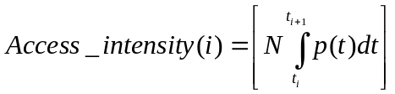
Where:
- t_{i} is the time of the i-th access opportunity.
- the distribution p(t) follows the Beta distribution:
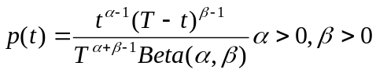, 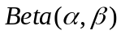 is the Beta function. The values of α=3 and β=4 are assumed in the study.
The distribution of access attempts should be limited in the time T:
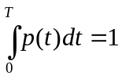

6.2 Methodology

6.2.1 Simulator methodology

6.2.1.1 Protocol level simulator methodology
A single cell environment is assumed.
In case of no collision, 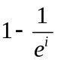 preamble detection probability is assumed, where i indicates the i-th preamble transmission (indicates the i-th SYNC_UL transmission for UMTS 1.28Mcps TDD), to take into account the effects of radio channels, for example path-loss, fading, inter-cell interference, etc.

6.2.1.2 Impacts on/from H2H traffic
For the purpose of RACH capacity evaluation, all RACH attempts are assumed to be initiated by MTC devices with no background noise caused by H2H UEs.

6.2.1.3 Statistics collection
For the purpose of RACH capacity evaluation, all the statistics in section 6.3 is collected for the period of time between the activation of the first MTC device and the (successful or unsuccessful) completion of the last random access procedure triggered by a MTC device. For LTE, successful completion of one random access procedure means the successful reception of Msg4. For UMTS, successful completion of one random access procedure means the complete of RACH message part.

6.2.2 Simulation assumptions

6.2.2.1 Simulation parameters for RACH capacity evaluation
This section defines the simulation parameters which may be required to conduct the study on the RACH capacity for MTC devices for different systems.
A first set of basic parameters is defined in Tables 6.2.2.1.1 – 6.2.2.1.4 to assess the RACH capacity of existing ‘MTC-agnostic’ networks. This means that typical parameter configurations are considered (and not ad-hoc MTC-specific ones).
Table 6.2.2.1.1: Basic simulation parameters for RACH capacity for LTE FDD
Parameter | Setting
Cell bandwidth | 5 MHz
PRACH Configuration Index | 6
Total number of preambles | 54
Maximum number of preamble transmission | 10
Number of UL grants per RAR | 3
Number of CCEs allocated for PDCCH | 16
Number of CCEs per PDCCH | 4
Ra-ResponseWindowSize | 5 subframes
mac-ContentionResolutionTimer | 48 subframes
Backoff Indicator | 20ms
HARQ retransmission probability for Msg3 and Msg4 (non-adaptive HARQ) | 10%
Maximum number of HARQ TX for Msg3 and Msg4 (non-adaptive HARQ) | 5

Table 6.2.2.1.2: Basic simulation parameters for RACH capacity for LTE TDD
Parameter | Setting
Cell bandwidth | 10 MHz
Uplink-downlink allocations configuration | 1
PRACH Configuration Index | 6
Total number of preambles | 54
Maximum number of preamble transmission | 10
Number of UL grants per RAR | 6
Number of CCEs allocated for PDCCH | 16
Number of CCEs per PDCCH | 4
Ra-ResponseWindowSize | 5 subframes
mac-ContentionResolutionTimer | 48 subframes
Backoff Indicator | 20ms
HARQ retransmission probability for Msg3 and Msg4 (non-adaptive HARQ) | 10%
Maximum number of HARQ TX for Msg3 and Msg4 (non-adaptive HARQ) | 5

Table 6.2.2.1.3: Basic simulation parameters for RACH capacity for UMTS FDD
Parameter | Setting
NB01min | 0
NB01max | FFS
Maximum number of preamble retransmissions | FFS
Max number of Preamble Ramping cycles | FFS
Dynamic persistence value | FFS
Number of signatures per PRACH | FFS
Number of PRACH | 1
Available access slots | All
RACH
RACH TTI | 20 ms
EUL in CELL_FACH
E-DCH TTI | FFS
Number of common E-DCH resources | FFS

Table 6.2.2.1.4: Basic simulation parameters for RACH capacity for UMTS 1.28Mcps TDD
Parameter | Setting
Cell bandwidth | 10 MHz
Mmax (Mac Layer Transmission Number) | 2
Number of signatures (SYNC_UL codes) | 8
Pi (transmission probability) | 0.3
Number of UpPCH Subchannel | 2
Number of FPACH | 8
Number of PRACH associated to each FPACH | 1
SF of PRACH | 1/4
RACH TTI | 5 ms
WT | 4 subframes
Physical Layer Transmission Number | 4
Number of uplink timeslots per carrier | 3

6.2.2.2 Handling of collision
For LTE FDD and TDD, if two (or more) MTC devices select the same preamble at the same time, it is assumed that the eNB will not be able to decode any of the preambles; hence, the eNodeB will not send the Random Access Response (RAR). MTC devices will only detect a collision if Msg2 (RAR) is not received in the ra-ResponseWindow.
For UMTS FDD, if one MTC device has started the transmission of the message part while another MTC device selects the same preamble, the Node B will send NACK on AICH to reject the second MTC device to avoid the collision. If two (or more) MTC devices select the same preamble at the same access slot, it is assumed that the Node B will not be able to decode any of the preambles; hence, the Node B will not send an ACK on the AICH.
For UMTS 1.28Mcps TDD, if a collision happens, e.g. two (or more) MTC devices select the same SYNC_UL code, it is assumed that all MTC devices which collide will not receive any FPACH response during WT (RA response window), and will re-enter into anther preamble ramping cycle.

6.2.2.3 Processing latency
For LTE, the assumed processing latency for each step is as per Table B.1.1.1-1 (for FDD) and Table B.1.1.2-1 (for TDD) in TR 36.912.

6.3 Output for analysis

6.3.1 Measures for RACH capacity evaluation
The following measures could be taken into account for the purpose of RACH capacity evaluation for MTC:
- Collision probability, defined as the ratio between the number of occurrences when two or more MTC devices send a random access attempt using exactly the same preamble and the overall number of opportunities (with or without access attempts) in the period.
- Access success probability, defined as the probability to successfully complete the random access procedure within the maximum number of preamble transmissions.
- Statistics of number of preamble transmissions, defined as the CDF of the number of preamble transmissions to perform a random access procedure, for the successfully accessed MTC devices.
- Statistics of access delay, defined as the CDF of the delay for each random access procedure between the first RA attempt and the completion of the random access procedure, for the successfully accessed MTC devices.
- Statistics of simultaneous preamble transmissions (for UMTS FDD), defined as the CDF of the number of MTC devices that transmit preamble simultaneously in an access slot. This serves an indirect measure of Rise over Thermal (RoT).
- Statistics of simultaneous data transmissions (for UMTS FDD), defined as the CDF of the number of MTC devices that transmit pilot or pilot AND data simultaneously in an access slot. This serves an indirect measure of Rise over Thermal (RoT).

6.4 Simulation results

6.4.1 Simulation results for RACH capacity
This section captures the simulation results for RACH capacity evaluation for MTC, based on the basic parameters defined in Tables 6.2.2.1.1 – 6.2.2.1.4.

6.4.1.1 LTE FDD
Table 6.4.1.1.1: Simulation results for RACH capacity for LTE FDD
Traffic Model | Performance measures | Number of MTC devices per cell
Traffic Model | Performance measures | 5000 | 10000 | 30000
1 | Collision Probability | 0.01% | 0.03% | 0.22%
1 | Access Success Probability | 100% | 100% | 100%
2 | Collision Probability | 0.45% | 1.98% | 47.76%
2 | Access Success Probability | 100% | 100% | 29.5%

Traffic Model | Number of preamble transmissions | Number of MTC devices per cell
Traffic Model | Number of preamble transmissions | 5000 | 10000 | 30000
1 | Average | 1.43 | 1.45 | 1.50
1 | 10th percentile | 1 | 1 | 1
1 | 90th percentile | 1.91 | 1.92 | 1.96
2 | Average | 1.56 | 1.77 | 3.49
2 | 10th percentile | 1 | 1 | 1
2 | 90th percentile | 2.14 | 2.77 | 7.33

Traffic Model | Access Delay (ms) | Number of MTC devices per cell
Traffic Model | Access Delay (ms) | 5000 | 10000 | 30000
1 | Average | 25.60 | 26.05 | 27.35
1 | 10th percentile | 15 | 15 | 15
1 | 90th percentile | 43.92 | 44.54 | 46.46
2 | Average | 29.06 | 34.65 | 76.81
2 | 10th percentile | 15 | 15.25 | 15.89
2 | 90th percentile | 51.61 | 65.71 | 174.39

6.4.1.2 LTE TDD
Table 6.4.1.2.1: Simulation results for RACH capacity for LTE TDD
Traffic Model | Performance measures | Number of MTC devices per cell
Traffic Model | Performance measures | 5000 | 10000 | 30000
1 | Collision Probability | 0.01% | 0.03% | 0.24%
1 | Access Success Probability | 100% | 100% | 100%
2 | Collision Probability | 0.59% | 10.21% | 52.12%
2 | Access Success Probability | 99.95% | 82.93% | 22.94%

Traffic Model | Number of preamble transmissions | Number of MTC devices per cell
Traffic Model | Number of preamble transmissions | 5000 | 10000 | 30000
1 | Average | 1.43 | 1.45 | 1.51
1 | 10th percentile | 1 | 1 | 1
1 | 90th percentile | 1.86 | 1.87 | 1.95
2 | Average | 1.79 | 3.42 | 4.43
2 | 10th percentile | 1 | 1 | 1
2 | 90th percentile | 2.6 | 6.78 | 8.41

Traffic Model | Access Delay (ms) | Number of MTC devices per cell
Traffic Model | Access Delay (ms) | 5000 | 10000 | 30000
1 | Average | 28.20 | 28.45 | 29.77
1 | 10th percentile | 17.5 | 17.5 | 17.5
1 | 90th percentile | 46.42 | 46.50 | 47.97
2 | Average | 36.44 | 87.77 | 102.94
2 | 10th percentile | 17.5 | 18.0 | 23.02
2 | 90th percentile | 64.66 | 190.31 | 196.01

6.4.1.3 UMTS FDD

6.4.1.4 UMTS 1.28Mcps TDD
Table 6.4.1.4.1: Simulation results for RACH capacity for UMTS 1.28Mcps TDD
Traffic Model | Performance measures | Number of MTC devices per cell
Traffic Model | Performance measures | 1000 | 3000 | 5000 | 10000 | 30000
1 | Collision Probability | 0.01% | 0.11% | 0.31% | 1.37% | 26.55%
1 | Access Success Probability | 100% | 100% | 100% | 100% | 94.67%
2 | Collision Probability | 0.9% | 19.38% | 43.54% | 62.16% | 77.52%
2 | Access Success Probability | 100% | 81.13% | 32.25% | 9.37% | 1.74%

Traffic Model | Number of preamble transmissions | Number of MTC devices per cell
Traffic Model | Number of preamble transmissions | 1000 | 3000 | 5000 | 10000 | 30000
1 | Average | 1.44 | 1.48 | 1.52 | 1.64 | 2.95
1 | 10th percentile | 1 | 1 | 1 | 1 | 1
1 | 90th percentile | 1.86 | 1.91 | 1.96 | 2.32 | 5.21
2 | Average | 1.66 | 2.96 | 3.15 | 3.03 | 3.09
2 | 10th percentile | 1 | 1 | 1 | 1 | 1
2 | 90th percentile | 2.40 | 5.68 | 6.10 | 5.92 | 6.08

Traffic Model | Access Delay (ms) | Number of MTC devices per cell
Traffic Model | Access Delay (ms) | 1000 | 3000 | 5000 | 10000 | 30000
1 | Average | 43.37 | 48.36 | 49.45 | 52.67 | 91.15
1 | 10th percentile | 25.10 | 25.15 | 25.21 | 25.86 | 29.88
1 | 90th percentile | 79.16 | 81.87 | 83.48 | 89.45 | 179.64
2 | Average | 52.51 | 90.51 | 96.03 | 92.73 | 94.52
2 | 10th percentile | 25.4 | 27 | 27 | 27 | 27
2 | 90th percentile | 90.65 | 191.00 | 201.50 | 196.50 | 201.50

7 Conclusion
[Editor’s note: This section captures the conclusion of the study. The section can be formulated in such way that the contents can be used as an input of further specification work.]
For RAN overload control, a number of candidate solutions were investigated during the study phase. As a result, Extended Access Barring (EAB) is believed to be a feasible solution and is adopted for RAN overload control. The different alternatives for EAB design could be further considered as part of a possible Work Item.

Annex A:
Traffic model for Machine-Type Communications
[Editor’s note: This section is intended to describe the typical traffic characteristics for different M2M applications with machine-type communications. A traffic model is presented for M2M services to be used to evaluate gains for the above RAN improvements for machine-type communications.]

Annex B:
Load Analysis for MTC

B.1 Example RACH Load Analysis for Smart Electric Metering Application
For the purpose of this analysis, the household density in central and urban areas of London is considered as an example.
According to the 2001 census data for London [4], the average number of people per household in Central London is 1.58 and 2.64 in an urban London Area. Figure B.1 shows the population density in London based on 2007 statistics [5].
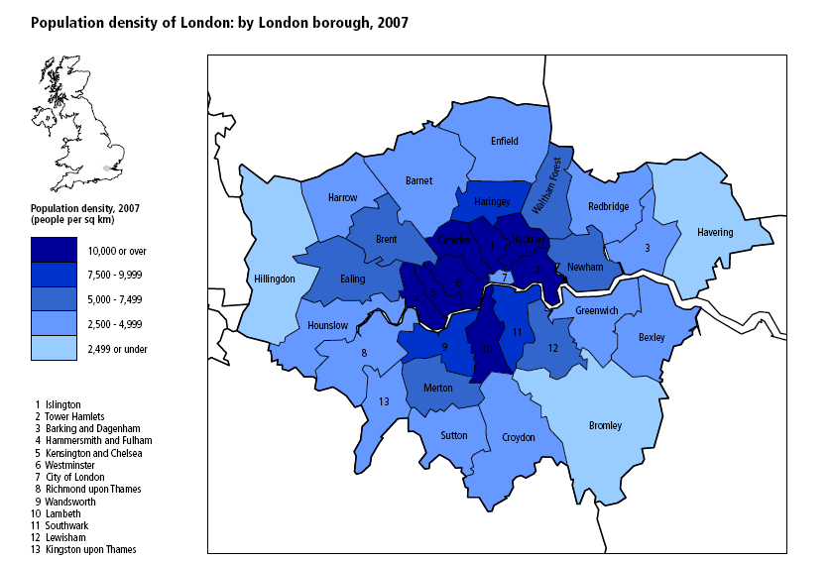
Figure B.1: Population Density in London
Based on the information provided by [4] and [5], the average number of households per square Km can be estimated and consequently the number of Smart Electric meters per cell for different cell radii (assuming each household has an electric meter). Table B.1 summarises the expected number of households per cell for typical cell radii. In the example scenario, it is assumed that all households with a smart electric meter within a cell are served by the same operator.
Table B.1: Predicted RACH intensity of Smart Meters
Area | Population Density/SqKm | Number of people /household | Average number of households /SqKm | Typical Cell Size/Km | No. Households/cell
Central London | 10000 | 1.58 | 6329 | 0.5 | 4968
Urban London | 7500 | 2.64 | 2840 | 2 | 35670

In [6], a smart meter density of 1000/sector is quoted for the US market. Analysis for this value is also taken into consideration for further evaluation.
The other factor that influences the RACH intensity generated by smart meters in a cell is the frequency with which the meters need to provide their reading. Smart meters can be used for a variety of applications such as for Automatic Meter Reading, Energy Demand Management and Micro Electric Generation management. According to [6], periodical reporting of meter readings in ranges of 5 mins, 15 mins, 1 hour, 6 hours, 12 hours and 24 hours are possible.
It is assumed that a concentrator serves a group of smart electric meters. G smart electric meters are grouped and connected to a concentrator. Readings from the meters of the same group are aggregated by the serving concentrator. A concentrator connects to eNB and reports to data centre periodically. The value of G is given by:
G = FFS (General Case)
or
G = 1 (Worst Case).
Table B.2 summarises the expected RACH intensity (Number of RACH attempts/s) for different periodicities of sending smart meter readings for the different regions considered. The calculations assume that the sending of meter readings is uniformly distributed over the required periodicity of sending the readings.
Table B.2: Predicted RACH intensity of Smart Electric Meters
Smart Electric Meter Reading Periodicity | RACH Intensity (RACH Attempts/s)
Smart Electric Meter Reading Periodicity | US market (1000 smart meters /sector) [6] | Central London (4968 households/cell) | Urban London (35670 households/cell)
5 mins | 3.3 | 16.6/G | 118.9/G
15 mins | 1.1 | 5.5/G | 39.6/G
30 mins | 0.6 | 2.8/G | 19.8/G
1 hour | 0.3 | 1.4/G | 9.9/G
6 hours | 0.05 | 0.2/G | 1.7/G
12 hours | 0.02 | 0.1/G | 0.8/G
24 hours | 0.01 | 0.06/G | 0.4/G

Synchronised Generation of RACH Attempts by Smart Meters
If Smart Electric meters do not distribute their RACH attempts over time, the generated RACH intensity will depend on the level of synchronisation of the generated RACH attempts. During the study, the possibility of all electric meters generating their attempts within 10 s (due to lack of clock synchronisation in smart meters) [7] and one minute due to alarms triggered by smart meters [6] have been indicated. With such tight synchronisation, the generated RACH intensity is summarised in Table B.3.
Table B.3: RACH Intensity Generated by Synchronised Smart Electric Meters
Synchronisation range | RACH Intensity
Synchronisation range | US Market (1000 smart meters per sector) [6] | Central London (4968 households/cell) | Urban London (35670 households/cell)
10s | 100 | 497/G | 3567/G
1 min | 17 | 83/G | 595/G

3. RACH Capacity of LTE
According to [7], an estimate of the RACH collision probability is given by:
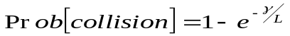,
where L is the total number of random-access opportunities per second and γ is the random-access intensity, i.e. there are, on average, γ random-access attempts per second and cell. The analysis assumes that there are a large number of devices in the cell which is valid for this scenario. Moreover, it is also assumed that the arrival of RACH requests is uniformly distributed over time.
In Section 2, the RACH intensity generated by smart meters was evaluated. The total number of RACH attempts per second depends on the PRACH configuration index as described in TS 36.211 [8]. Table B.4-1 summarises some possible values of RACH opportunities/s/preamble for different PRACH configuration index value for LTE frame structure type 1. Table B.4-2 summarises some possible values of RACH opportunities/s/preamble for different PRACH configuration index value for LTE frame structure type 2 UL/DL configuration 1.
Table B.4-1: Number of RACH opportunities/s/Preamble for Frame Structure Type 1
PRACH Configuration Index | % resources consumed in a 5MHz bandwidth | Number of RACH opportunities/s/preamble
0 | 1.25 | 50
6 | 5 | 200
9 | 7.5 | 300
12 | 12.5 | 500
14 | 25 | 1000

Table B.4-2: Number of RACH opportunities/s/Preamble for Frame Structure Type 2 UL/DL Configuration 1
PRACH Configuration Index | % resources consumed in a 10MHz bandwidth | Number of RACH opportunities/s/preamble
0 | 1.5 | 50
3 | 3 | 100
6 | 6 | 200
9 | 9 | 300
12 | 12 | 400
15 | 15 | 500
18 | 18 | 600

For a given collision probability Pc, the required number of RACH opportunities to support a certain RACH intensity is given by:
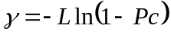
In Figure B.2, a plot of the supported RACH intensity against the required number of RACH opportunities is provided.
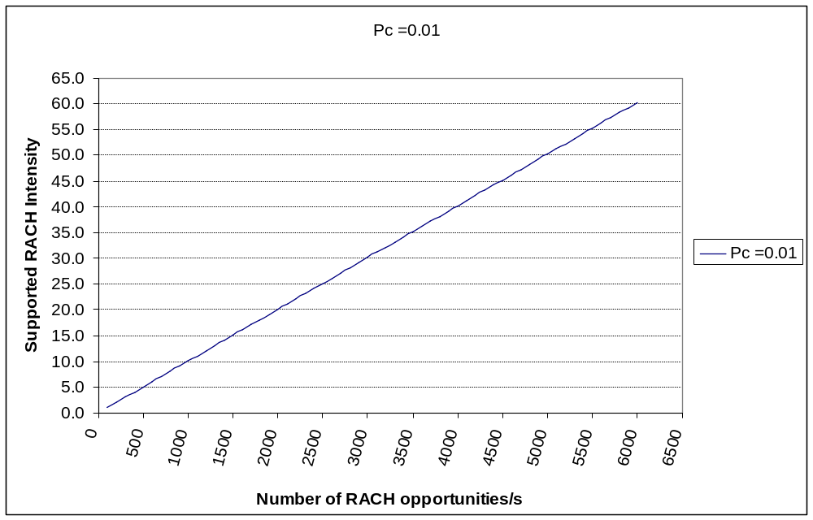
Figure B.2: Supported RACH Intensity against number of RACH opportunities per second for a given collision probability of 1%.

B.2 Example RACH Load Analysis for Fleet Management Application
Fleet management is becoming a popular M2M application in China. In many metropolises of China, taxis are equipped with the devices which can report their latest location information periodically or on demand. Upon receiving requests, the taxi company can schedule the nearby available taxi to serve the passengers so that the efficiency of taxi and customer satisfaction can be improved. Timely location information can also be used to track freight and stolen vehicles. Another important usage of location information is to calculate the velocity of vehicles, which can be used by the traffic management department to estimate the traffic intensity of a certain area. The higher the velocity, the less the traffic jam, and vice versa. Then the traffic status information can be distributed timely to help people to avoid the congested area.
Currently, the fleet management application has been deployed in many cities of China using GPRS/EDGE network. In Beijing, there are around 80,000 taxis now, and more than 90% of them, i.e. more than72,000 taxis, have been equipped with the fleet management devices. The most frequent location report happens with the interval of 5 seconds, and periodicity of 10-15 seconds is a typical configuration [9].
When a large number of vehicles using fleet management service gather in a cell, overload may happen since the location information report is always in the frequency of seconds. One typical RACH overload scenario that has been observed in CMCC’s GERAN network appears in the taxi area of airport. For example, such kind of overload is observed often in Beijing Capital International Airport, since it is normal that there are hundreds of taxis (even more than 1000 during the peak time) queued for passengers. The overload caused by fleet management application is also observed in the headquarters of taxi companies. It is typical in China that taxi companies organize a meeting periodically, resulting in hundreds of taxis assemble in a small area.
Such kind of congestion has been observed in existing GERAN network due to MTC devices, and whether this situation will appear if similar fleet management application continues to be deployed in LTE network needs to be analyzed. To transfer the fleet management data, following two options could be considered.
Keeping the device in connected mode only when transferring the location information
Due to small amount of the location information data, i.e. around 100 bytes, the data transfer could be completed in a very short time. After that, the RRC connection could be released very soon and initial access procedure could be re-performed when the new location information coming from upper layer.
Keeping the device in connected mode all the time
In this case, it is no need to perform initial access every time when location information report is pending. However, it seems inefficient and difficult to keep the device uplink time aligned between location reports, since typically the transmission interval is in the order of tens of seconds (e.g. 10-15s) and the device moves together with vehicle. Therefore, every time when the device wants to send the location information, normally the uplink synchronization has been lost and random access procedure still needs to be initiated. Additionally, extra random access has to be performed due to handover, if keeping this kind of device in connected mode. For instance, assuming that the cellular radius in Beijing urban area is about 300m and the average velocity of vehicle is 40km/h, handover happens for every 27s. Frequent handovers will possibly burden the load of random access as well.
Observation 1: No matter whether or not always keeping the fleet management device in connected mode, at least random access is needed every time the location information coming from upper layer.
For the airport scenario, assuming that there are 800 taxis aggregating in one cell and 90% of them need to send their location information. Assuming that reporting interval is 10 seconds and reporting time across taxis is uniformly distributed, the RACH intensity (number of RACH attempts/s) generated by taxis is about 800*90%/10=72.
As for the case of meeting at taxi company, there are also hundreds of taxis aggregating in one cell, e.g. 400. All of them are equipped with fleet management devices once the company has subscribed to the service. Then the RACH intensity is about 400/10=40 attempts/s.
Observation 2: The RACH intensity generated by taxis with fleet management services could be as high as 72 and 40 RACH attempts/s in the cell of Beijing Capital International Airport and taxi company, respectively.
To support this RACH intensity for a collision probability of 1%, around 7200 RACH opportunities/s are required for airport case [10]. If PRACH configuration index of 6 [8] is used, for each preamble there are 200 RACH opportunities per second. Hence, 7200/200=36 preambles are needed to support the fleet management application.

B.3 Example RACH Load Analysis for Earthquake Monitoring Application
With more and more attention on earthquake prediction mechanisms, in several countries it is highly desired that earthquake monitoring networks will be deployed in the near future. The earthquake monitoring scenario is one of the examples where a large number of MTC devices in a specific area can be almost simultaneously triggered by a sudden event to start RA procedures, and where the RA attempts cannot be uniformly spread in time.
In the following, the evaluation of RACH congestion in the earthquake monitoring scenario is given, assuming a density of 10 MTC devices per square km, which can also account for possible ‘concentrators’ of the signals received by individual earthquake sensors. Assuming a cell radius of 2Km, then the sensors density per cell would be 126. Considering that the typical speed of seismic surface waves is 4Km/s, then it will take 1 second for the wave to pass through the whole cell, which means the sensors in the cell will be triggered with nearly uniform distribution and the RA attempts density will be 126/cell/s.
Assuming that a typical PRACH configuration index 6 is adopted, to achieve a RACH collision probability lower than 1%, all the available 64 preambles would be required
P [collision] = 1- e ^{-126/(200*64)} = 0.0098
It is worth mentioning that the current back off mechanism and barring mechanism of access control may be unacceptable in the earthquake scenario, because even tens of milliseconds are very important for an earthquake alarm.
These calculations suggest that earthquake monitoring applications can put some some serious requirements on RACH congestion handling, and that specific solutions might have to be considered.

B.4 Preliminary RACH Load Analysis for HSPA and LTE
The random access for HSPA and LTE were dimensioned to provide service to a target of UEs. Due to uncoordinated random access, RACH has a clearly limited capacity.
MTC devices, depending on the way they create traffic, might eventually overcome the RACH capacity. Annex B.1 indicated that in UK, the expected number of devices in urban areas is above 35000 and in US, the expected number of devices is in the order of 1000.
In both cases, it is obvious that if all those 35000 or 1000 devices start their random access at the same time – same random access slot – in a synchronous fashion, the RACH capacity for that slot will be exceeded.
For FDD, from the interference point of view, a rush of random access accesses will increase the UL thermal noise which may affect other UEs. At the same time, in one access slot, the Node B can only send a limited amount of AICH in the DL. Devices which do not receive an AICH will access during next access slot even with a higher power increasing the interference in the system. Last but not least, the Node B has a limited amount of RACH HW receivers which may limit the amount of UEs transmitting at the same time. Similar limitations are also present in LTE.
For 1.28Mcps TDD, 8 SYNC_UL at most can be used in one random access slot, i.e. one UpPTS, which means limited number of devices can initial the random access at the same time. The Node B can only send a limited amout of FPACH in the DL, depending on the system configuration. Last but not least, limited amount of RACH resource can be configured depending on the configuration of UL timeslots in the cell.
RACH HSPA - ASC Simulation Results for UTRAN FDD
In these simulations, an ASC has been created so that a sub-set of signatures is used for MTC devices. An ASC is defined by a set of RACH channels (i.e. access slots in which the device can start its transmission), by a dynamic persistence value, and by a set of signatures.
It has been also considered that all MTC devices arrive to the network uniformly distributed within 1, 2, and 3 minutes.
The basic simulation parameters are below:
Number of MTC devices |  | 1000
Arrival time |  | Uniform distribution – 1, 2, 3 minutes
Application packet size |  | 200 Bytes (+ UDP/IP headers)
Back-off parameters
 | NB01min | 0
 | NB01max | 30
ASC
 | Number of signatures | 4
 | Dynamic persistence value | 0.3, 0.3, 0.5 (for 1, 2 and 3 minutes respectively)
 | Available access slots | All
RACH receivers |  | 5
RACH TTI |  | 20 ms

Figure B.3 shows the CDF to access the network, i.e. the time from the beginning of the random access at the MAC layer until the device receives the ACK on the AICH. Note that due to limited data rate available on RACH, each MTC device will need to perform several accesses in order to send completely the 200 bytes (+ headers) of data.
Figure B.4 shows the CDF of the time required for MTC device to complete the transmission of its data.
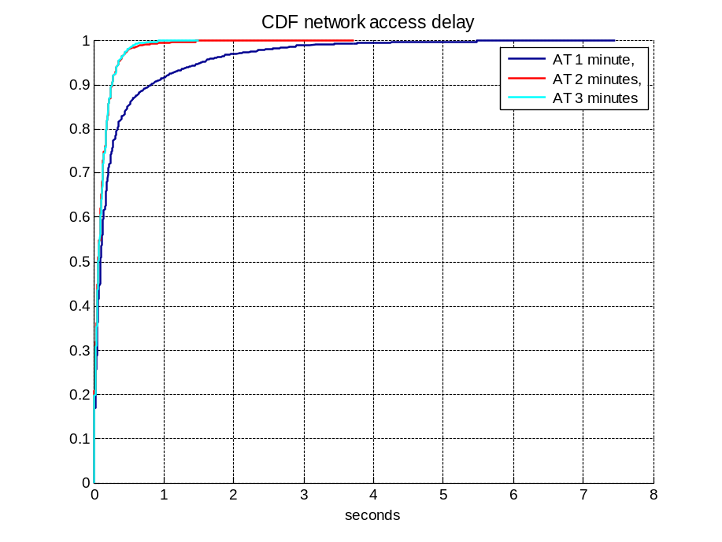
Figure B.3: CDF of the access delay
We can observe that if the MTC devices start their application transmissions within 1 minute, 90% of the devices will take less than 1 second to access the network when they try to access the network to send a piece of their data.
On the other hand, when those 1000 devices are distributed over 2 or 3 minutes, virtually all will access the network within 0.5 seconds. In the case of 3 minutes, the time to access the network could have been reduced even further if the persistence value would have been higher and the maximum back-off value would have been reduced. In the worse scenario, a device would wait for 300 ms to re-try again to access the network after receiving a NACK on the AICH. These parameters may be too conservative in case the NW has enough resources and the network is aware of the intensity of those devices.
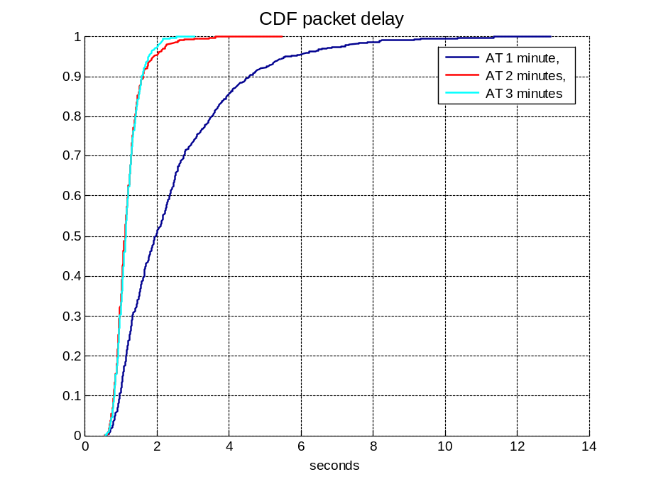
Figure B.4: CDF of the transmission time
Since the data needs to be sent using several RACH transmissions, it will take up to 5 seconds for 90% of the MTC devices to complete the transmission of the whole data if the devices are distributed within 1 minute time. The situation improves considerably if the devices arrive to the network distributed within longer period of time.
RACH LTE
These simulations show the packet delay (time since the application layer sends the data to lower layers until the packet is received) when a different number of MTC devices access the network. For this purpose, the number of MTC devices has been set to 1200 and 30000 devices. Users arrive randomly spread during one minute, transmit the packet and leave the system.
The MTC devices are assumed to be in RRC Idle. Application layer packets with the size of 200 bytes are transmitted to the device using UDP/IP. RLC AM is configured.
In LTE, the RACH could be configured to occur once every subframe up to once every other radio frame. For the simulations presented below, we have assumed that the RACH occurs every 5 ms. 10 preambles are configured to be dedicated; therefore, the other 54 can be used for the random access. Considering these assumptions, we end up having 200 RACH opportunities per second and a total of 10800 preambles per second.
UEs are granted access to the network in the Random Access Response (RAR). One or more RAR can be sent within certain window corresponding to one RACH opportunity. A UE will wait for that period of time to receive the RAR. In these simulations, it has been considered that only up to 3 users are provided with an UL grant per RAR. If the UE does not receive the RAR, the UE will try to access the network with higher power. Contention resolution is not explicitly modelled; instead, both users will restart their random access procedure in case of contention.
PDCCH is the channel used to give a grant to a UE after the eNode-B sends the RAR and to indicate the presence of RAR. It has been assumed that the PDCCH can only send up to 3 grants per subframe. Assignments take into consideration that signalling traffic has absolute priority. In other words, the network will provide first grants to those UEs which need to send signalling data. LTE access procedure requires at least 2 uplink and 2 downlink grants and another uplink and downlink grant for the data transaction (see Figure B.6). Hence, given the assumptions above, there is a theoretical cap on the capacity of 54 000 random access attempts per minute.
Finally, the simulations have been done considering single cell simulations on 5 MHz.
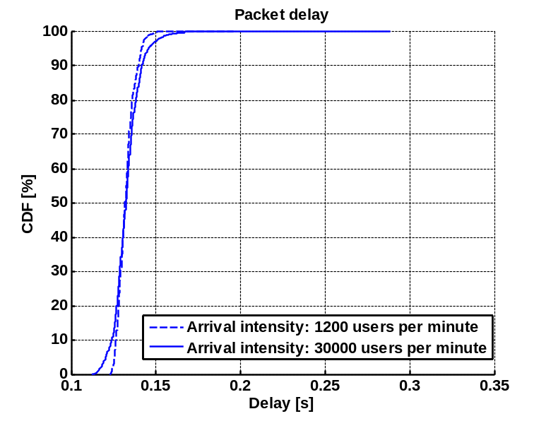
Figure B.5: CDF of the transmission time
It can be observed that, for high load, a small amount of MTC devices will experience lower packet delay than for low load. Figure B.6 can assist to understand this effect.
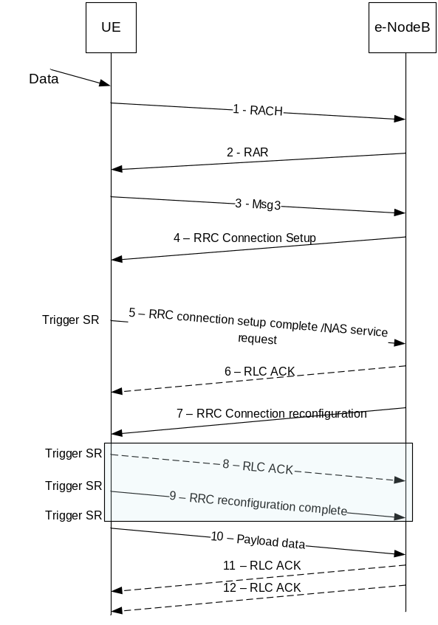
Figure B.6: Message sequence to transmit data of a UE in RRC Idle
The reason for the lower packet delay resides in messages 8 and 9. Upon generating the RLC ACK, the UE triggers the Scheduling Request (SR). The NW sends a scheduling grant in the PDCCH almost immediately. At this point, the UE has not yet processes the RRC connection reconfiguration message and it does not have available the RRC Reconfiguration complete message. Once it is ready, the UE triggers another SR to request a grant and when it gets it, the UE sends the message.
For high load, when the UE sends the SR to send the RLC ACK, the PDCCH load is such that the PDCCH is not sent immediately. It takes several milliseconds. In some cases, when the PDCCH is received by the UE, the RRC connection reconfiguration has been processed and the RRC reconfiguration complete message is ready to be sent. If the received grant allows, the UE sends message 8 (RLC ACK) and message 9 (RRC reconfiguration complete) together.
This behavior can be observed in Figure B.7.a and B.7.b. The former figure shows the trace of a UE in a low load situation. As explained above, messages 8 and 9 are sent separately in different times. On the later figure, messages 8 and 9 are sent together. The clear consequence is that message 10 (data) is sent earlier than in the case of low load; hence, reducing the packet transmission delay.
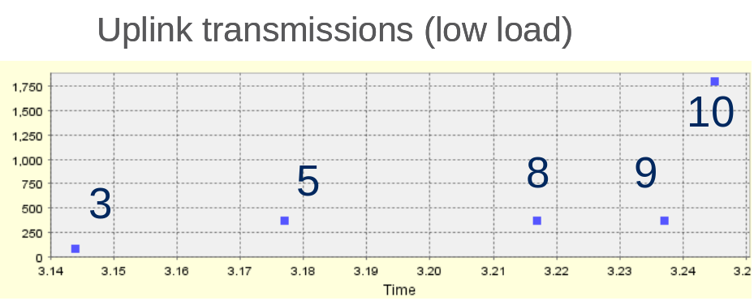
Figure B.7.a: Sample uplink trace for low load
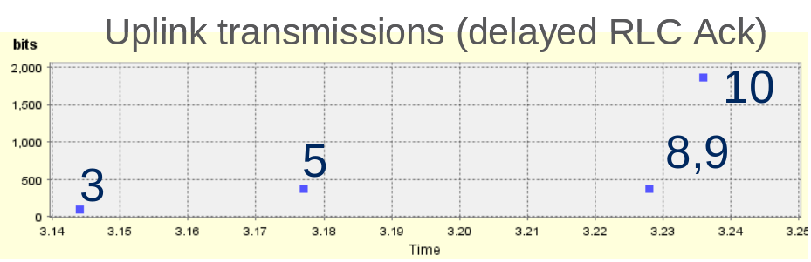
Figure.7.b: Sample uplink trace for high load
RACH HSPA - ASC Simulation Results for UTRAN 1.28Mcps TDD
For 1.28Mcps TDD, the RACH capacity is impacted by the configured random access parameters, i.e. the number of FPACH(s), the Speading Factor and the TTI of RACH channel(s), maximum numbers of SYNC_UL transmissions in physical layer, maximum number of synchronisation attempts in MAC layer and the configuration of ASC parameters.
In this simulation, both the SYNC_UL retransmissions in physical layer and the synchronisation attempts in MAC layer are taken into account. To achieve the “best” RACH capacity, the number of the FPACH/PRACH pairs configured for the cell, i.e. on the primary frequency is set as 8 in the simulation. Simulations for other FPACH/PRACH configuration case(s) should be done and the detailed configuration parameters of FPACH/PRACH are FFS.
It is assumed that the arrival of RACH requests matches the Poisson distribution.
The basic simulation parameters are below:
RACH attempt failure ratio |  | 1%
MAC Layer Parameters
Mmax (Mac Layer Transmission Number) |  |  | 1, 2, 3, 4
ASC
 | Number of signatures (SYNC_UL codes) |  | 8
 | Pi (transmission probability) |  | 0.3, 1.0
Physical Layer Parameters
Number of FPACH |  |  | 8
Number of PRACH associated to each FPACH |  |  | 1
SF of PRACH |  |  | 1/4
RACH TTI |  |  | 5 ms
WT |  |  | 1 (subframe)
Physical Layer Transmission Number |  |  | 1, 2, 4, 8

NOTE: The RACH attempt failure means that for a device, the maximum number of synchronisation attempts of MAC layer (Mmax) is achieved but it still fails to access to the network.

Annex C:
Change history
Change history
Date | TSG # | TSG Doc. | CR | Rev | Subject/Comment | Old | New
2010-01 | RAN2 #68bis | R2-100847 | - | - | Agreed skeleton TR at RAN2 #68bis | - | 0.1.0
2010-02 | RAN2 #69 | R2-101801 | - | - | Captured agreements of R2-091327 | 0.1.0 | 0.1.1
2010-02 | RAN2 #69 | R2-101892 | - | - | Agreed version at RAN2 #69 | 0.1.1 | 0.2.0
2010-04 | RAN2 #69bis | R2-102629 | - | - | Captured agreements of RAN2 #69bis | 0.2.0 | 0.2.1
2010-04 | RAN2 #69bis | R2-102657 | - | - | Agreed version at RAN2 #69bis and captured agreements of R2-102628 | 0.2.1 | 0.3.0
2010-05 | RAN2 #70 | R2-103401 | - | - | Captured agreements of RAN2 #70 and agreed TP from R2-103269, R2-103141, R2-102824 | 0.3.0 | 0.3.1
2010-05 | RAN2 #70 | R2-103454 | - | - | Agreed version at RAN2 #70 | 0.3.1 | 0.4.0
2010-06 | RAN2 #70bis | R2-104080 | - | - | Captured agreed TP from R2-103691 and R2-103692 | 0.4.0 | 0.4.1
2010-06 | RAN2 #70bis | R2-104207 | - | - | Agreed version at RAN2 #70bis | 0.4.1 | 0.5.0
2010-08 | RAN2 #71 | R2-104963 | - | - | Captured agreements of RAN2 #71 | 0.5.0 | 0.5.1
2010-09 | RAN2 #71 | R2-105246 | - | - | Agreed version at RAN2 #71 and captured agreements of R2-104999 | 0.5.1 | 0.6.0
2010-10 | RAN2 #71bis | R2-106033 | - | - | Agreed simulation assumptions and results for RACH capacity evaluation | 0.6.0 | 0.7.0
2011-05 | RAN2 #74 | R2-113658 | - | - | Captured agreed TP from R2-113414 | 0.7.0 | 0.7.1
2011-05 | RAN2 #74 | R2-113685 |  |  | Agreed version at RAN2 #74 | 0.7.1 | 0.8.0
2011-08 | RAN2 #75 | R2-114569 |  |  | Agreed conclusion for the study on RAN overload control | 0.8.0 | 0.8.1
2011-08 | RAN2 #75 | R2-114815 |  |  | Agreed version at RAN2 #75 | 0.8.1 | 1.0.0

